**DUBAI ITINERARY 4N/5D**

**Tentative Schedule:**

**DATE DAY FLT NO SECTOR DEP ARR DURATION**

10FEB20 MON EK 571 KOLKATA DUBAI 0855 1250 5.25 HRS

14FEB20 FRI EK 572 DUBAI KOLKATA 1315 1850 4.05 HRS

**Day wise Itinerary**:

**Day 1:   10FEB MON**

13.10 hrs :           Arrival at Dubai airport, meet our local representative after clearing the immigration.

14.30 hrs:            Transfer to restaurant for lunch.

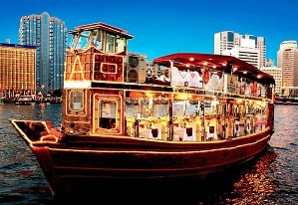15.30 hrs :           Check in to the hotel.

19.00 hrs :           Proceed  with dinner

23.00 hrs :           Return back to hotel and overnight stay .

**Day 2: 11FEB TUE**

08.00 hrs :           Breakfast at the hotel.

09.30 hrs :           Proceed for City tour visit some unique land marks of Dubai incl. Miracle Garden

14.00 hrs :           Lunch at the restaurant.

15.30 hrs :           Enjoy bird’s eye view from 124th floor of .

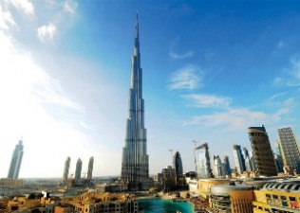17.00 hrs :           Free time for shopping

20.00 hrs :           Transfer for dinner at the restaurant.

21.00 hrs:            Dinner at the restaurant and overnight at the hotel.

**Day 3: 12FEB WED**

08.00 hrs :           Breakfast at the hotel.

Morning is at leisure

13.00 hrs :           Lunch at the restaurant.

15.00 hrs :           Pick up from restaurant and proceed for Desert safari with BBQ dinner and dune bashing.

21.00 hrs :           Drop back to the hotel after safari. Overnight at the hotel.



**Day 4**: **13FEB THU**

08.00 hrs :            Breakfast at the hotel

09.00 hrs :            Proceed for full day Abu Dhabi city  tour

11.30 hrs :           Visit .

13.00 hrs :           (Lunch inside the park).

19.00 hrs :           Evening return to Dubai.

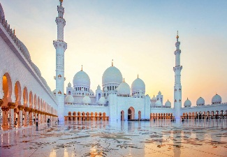21.00 hrs:            Dinner at the restaurant and overnight at the hotel.

**Day 5: 14FEB FRI**

08.00 hrs :           Breakfast at the hotel.

09.00 hrs :           Check out from hotel after breakfast.

10.00 hrs :           Transfer to airport for return flight back to India by EK 572



**For Club7 holidays Ltd.**